For recursion:  
Base Condition &

Choice Diagram

**0-1 Knapsack Memoization:**

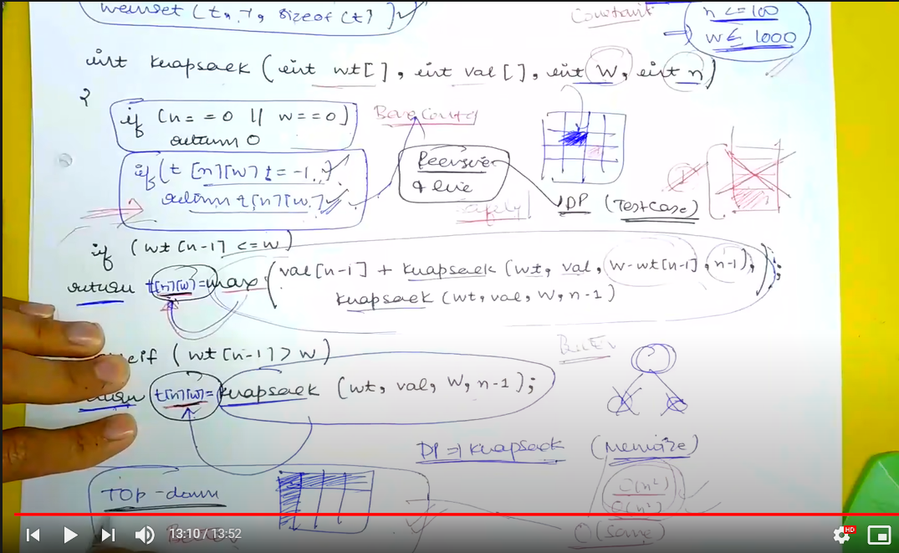

**Tabulation Method:**

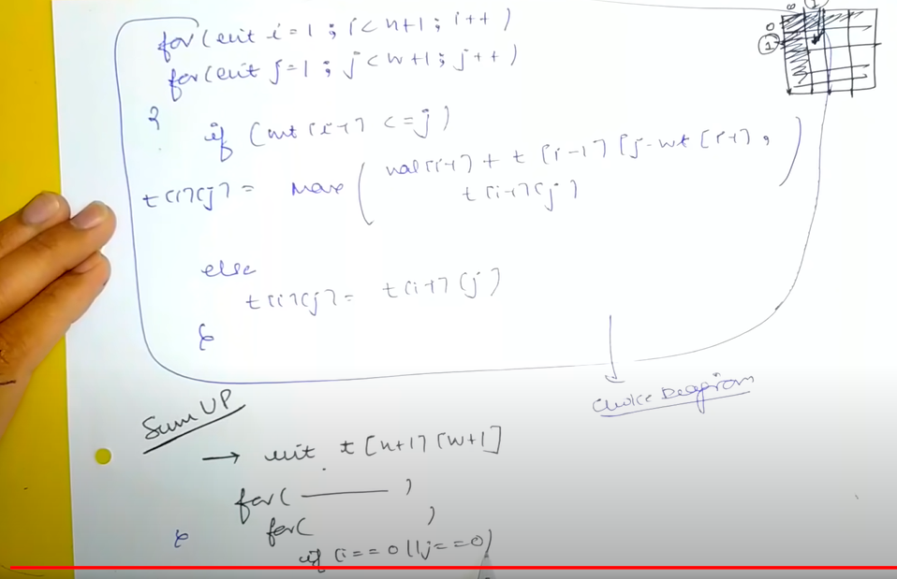

Questions:  
1/ how is its time complexity same as to that of top down when its being called recursively?

So the basic difference is that,  
in topdown or memoization,  
what you do is: you look for the recursive call and if some recursive call has been called already and has some value in that case, you do not further make recursive call but return with the value at that place  
so, it is a recursion wherein apply recursion but with strictness that you do not repeat the same recursion again and again  
  
and it bottom up or say tabulation ,  
what you do is:  
you do not have recursion at all.

The base condition of recursive function is the initialization for bottom up or tabulation method.